9.36: Since the rod is 500 times as long as it is wide, it can be considered slender.
- From Table 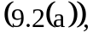

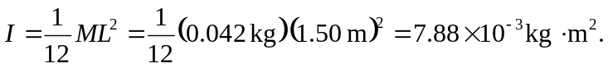

- From Table 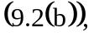

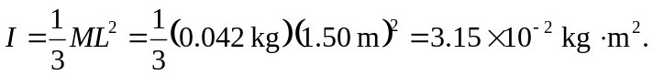

c) For this slender rod, the moment of inertia about the axis is obtained by considering it as a solid cylinder, and from Table 